Solutions: OCR Core Mathematics C1
January 2007

1 | $$\begin{aligned}\frac{5}{2−\sqrt{3}}=\frac{5}{2−\sqrt{3}}´\frac{2+\sqrt{3}}{2+\sqrt{3}} \\ =\frac{\text{10}+5\sqrt{3}}{4+2\sqrt{3}−2\sqrt{3}−3} \\ =\frac{\text{10}+5\sqrt{3}}{1} \\ =\text{10}+5\sqrt{3}\end{aligned}$$
2 (i) | $$6^{0}=1$$
(ii) | $2^{−1}´{\text{32}}^{4/5}$:  Write 32 as $2^{5}$.  We then get: $2^{−1}´(2^{5})^{4/5}=2^{−1}´2^{4}=2^{3}=8$
3 (i) | $$3(x−5)≤\text{24}$$  Expand out brackets: $3x−\text{15}≤\text{24}$  Add 15: $3x≤\text{39}$  Divide by 3: $x≤\text{13}$
(ii) | $$5x^{2}−2>\text{78}$$  This is a simple quadratic inequality.  Rearrange to make RHS equal to 0: $5x^{2}−\text{80}>0$  Divide through by 5: $x^{2}−\text{16}>0$  Now consider the equivalent quadratic equation: $x^{2}−\text{16}=0$  This can be factorised (difference of squares): (x + 4)(x – 4) = 0  So the solutions are: x = -4 or x = 4.  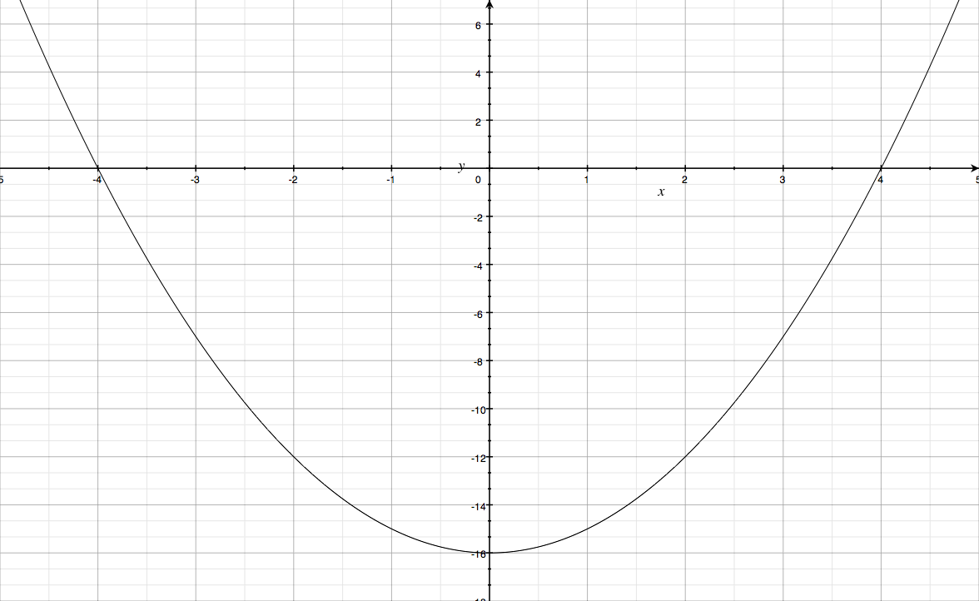  To get the solutions for the inequality, consider the graph of y = x² – 16:  We see x > 4 or x < -4.

4 | The equation $x^{\frac{2}{3}}+3x^{\frac{1}{3}}−\text{10}=0$ is a quadratic equation in disguise.  Use the substitution $y=x^{1/3}$ . The equation becomes: $y^{2}+3y−\text{10}=0$  This factorises: (y + 5)(y – 2) = 0  So the solutions are y = -5 or y = 2.  To get the solutions for x, we use x = y³: i.e. x = (-5)³ = -125 or x = 2³ = 8.
5 (i) | The graph for y = -f(x) is obtained by reflecting in the x-axis.
(ii) | The transformation which takes the graph to y = 3f(x) is a stretch scale factor 3 in the y-direction. So the coordinates of Q are (1, 3).
(iii) | The transformation which maps the graph to y = f(x + 2) is a translation 2 units to the left.
6 (i) | $$\begin{aligned}2x^{2}−\text{24}x=2[x^{2}−\text{12}x] \\ =2\left[(x−6)^{2}−\text{36}\right] \\ =2(x−6)^{2}−\text{72}\end{aligned}$$  Therefore,  $\begin{aligned}2x^{2}−\text{24}x+\text{80}=2(x−6)^{2}−\text{72}+\text{80} \\ =2(x−6)^{2}+8\end{aligned}$
(ii) | The equation of the line of symmetry is x = 6. (This is taken from the bracket)
(iii) | The equation of the tangent at the minimum point is y = 8 (This is because the minimum point has coordinates (6, 8).

7 (i) | If y = 5x + 3, then $\frac{\text{dy}}{\text{dx}}=5$
(ii) | If $y=\frac{2}{x^{2}}=2x^{−2}$ (write as a negative power), then $\frac{\text{dy}}{\text{dx}}\text{=-}4x^{−3}$.  Rule: Bring down the old power and subtract 1 from the power to get the new power.
(iii) | First expand out the brackets: $y=\text{10}x^{2}−9x−7$  Then differentiate to get: $\frac{\text{dy}}{\text{dx}}=\text{20}x−9$
8 (i) | The steps to find the coordinates of the stationary points are:  - Differentiate the curve to get $\frac{\text{dy}}{\text{dx}}$;  - Solve the equation $\frac{\text{dy}}{\text{dx}}$=0 in order to get the x-coordinates of the stationary points;  - Find the y-coordinates using the equation of the curve.  Here, $\frac{\text{dy}}{\text{dx}}=9−6x−3x^{2}$.  Therefore we need to solve the equation $9−6x−3x^{2}=0$  To make this equation easier to solve we could first change the signs: $3x^{2}+6x−9=0$  And then we could divide through by 3: $x^{2}+2x−3=0$  This then factorises as: (x + 3)(x – 1) = 0  So there are stationary points at x = -3 or x = 1.  We can find the y-coordinates of these points using the formula for the equation of the curve:$y=\text{27}+9x−3x^{2}−x^{3}$  When x = 1, y = 27 + 9 – 3 – 1 = 32  When x = -3, y = 27 – 27 – 27 + 27 = 0.  So the stationary points have coordinates (-3, 0) and (1, 32).
(ii) | To decide whether the stationary points are maximum or minimum points we follow these steps:  - Find the second derivative $\frac{d^{2}y}{{\text{dx}}^{2}}$  - Calculate the value of the second derivative at each of the stationary points  - If $\frac{d^{2}y}{{\text{dx}}^{2}}$ > 0, then it is a minimum point.  If $\frac{d^{2}y}{{\text{dx}}^{2}}$ < 0, then it is a maximum point.  Here, $\frac{d^{2}y}{{\text{dx}}^{2}}\text{=-}6−6x$.  When x = 1, $\frac{d^{2}y}{{\text{dx}}^{2}}\text{=-}6−6(1)\text{=-}\text{12}<0$ so a maximum point.  When x = -3, $\frac{d^{2}y}{{\text{dx}}^{2}}\text{=-}6−6(−3)=\text{12}>0$ so a minimum point.
(iii) | 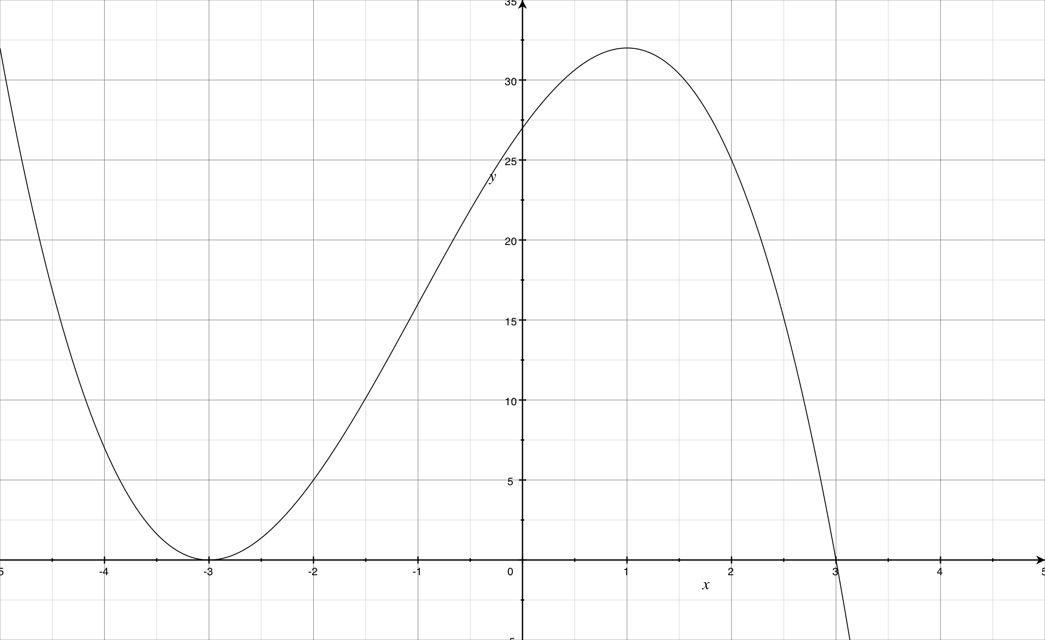  To decide where the curve is increasing, it is helpful to use the coordinates of the stationary points to help us to sketch the curve:  We see that it is increasing for  -3 < x < 1.
9 (i) | Parallel lines have the same gradient.  The line y = 4x – 5 has gradient 4.  So a parallel line also has gradient 4.  The equation of a line with gradient m passing through the point (a, b) is  $y−y_{1}=m(x−x_{1})$.  As our line must pass through the point (2, 7) its equation must be:  $y−7=4(x−2)$  i.e. y – 7 = 4x – 8  i.e. y = 4x – 1.
(ii) | You can calculate the distance between two points EITHER by sketching a diagram and using Pythagoras’ theorem OR by using the following result:  The distance between the points $(x_{1},y_{1})\text{, }(x_{2},y_{2})$ is  $\sqrt{(x_{2}−x_{1})^{2}+(y_{2}−y_{1})^{2}}$  If we use this formula here, the distance between A(2, 7) and B(-1, -2) is:  $\sqrt{(−1−2)^{2}+(−2−7)^{2}}=\sqrt{(−3)^{2}+(−9)^{2}}=\sqrt{\text{90}}$  This can be simplified to make $3\sqrt{\text{10}}$
(iii) | The gradient of AB is $\frac{−2−7}{−1−2}=\frac{−9}{−3}=3$  The midpoint of AB is (0.5, 2.5)  The gradient of a perpendicular line is $\frac{−1}{3}$ (i.e. the negative reciprocal).  So the equation of a perpendicular line is: $y−\frac{5}{2}\text{=-}\frac{1}{3}(x−\frac{1}{2})$.  Multiply by 6: $6y−\text{15}\text{=-}2(x−\frac{1}{2})$  i.e. 6y – 15 = -2x + 1  The equation therefore is 2x + 6y -16 = 0  Or x + 3y – 8 = 0.
10 (i) | The circle has equation $x^{2}+y^{2}+2x−4y−8=0$  To find the coordinates of the centre and the value of the radius, we need to rewrite the equation in the form $(x−a)^{2}+(y−b)^{2}=r^{2}$  We do this using completing the square:  $x^{2}+2x=(x+1)^{2}−1$  $y^{2}−4y=(y−2)^{2}−4$  The equation of the circle therefore is: $(x+1)^{2}−1+(y−2)^{2}−4−8=0$  Or $(x+1)^{2}+(y−2)^{2}=\text{13}$  The circle has centre (-1, 2) and radius √13.
(ii) | Substitute the coordinates (-3, k) into either equation of the circle.  The algebra is easier if we substitute into $(x+1)^{2}+(y−2)^{2}=\text{13}$.  We get: $(−3+1)^{2}+(k−2)^{2}=\text{13}$  i.e. $4+(k−2)^{2}=\text{13}$  i.e. $(k−2)^{2}=9$  Square rooting both sides: k – 2 = ±3  So the solutions are k = 5 or k = -1.  As k < 0, the only solution is k = -1.
(iii) | The equation of the line is x + y = 6 OR y = 6 – x.  If we substitute this into the equation of the circle $x^{2}+y^{2}+2x−4y−8=0$, we get:  $x^{2}+(6−x)^{2}+2x−4(6−x)−8=0$  Expanding out the brackets gives:  $x^{2}+\text{36}−\text{12}x+x^{2}+2x−\text{24}+4x−8=0$  Simplifying:  $2x^{2}−6x+4=0$  Divide by 2:  $x^{2}−3x+2=0$  This factorises as (x – 1)(x – 2) = 0 so the solutions are x = 1, x = 2.  When x = 1, y = 5  When x = 2, y = 4  Therefore the coordinates of the points of intersection are (1, 5), (2, 4).

