Solutions: Core Mathematics 1
January 2008

1 | $$\frac{4}{3−\sqrt{7}}=\frac{4}{3−\sqrt{7}}´\frac{3+\sqrt{7}}{3+\sqrt{7}}$$  = $\frac{\text{12}+4\sqrt{7}}{9−3\sqrt{7}+3\sqrt{7}−7}$  = $\frac{\text{12}+4\sqrt{7}}{2}$  = $6+2\sqrt{7}$
2 (i) | The equation of a circle centre (0, 0) radius r is $x^{2}+y^{2}=r^{2}$ (Learn this!)  So if the radius is 7, the equation is $x^{2}+y^{2}=\text{49}$
(ii) | There are various ways to tackle this question.  The equation of the circle is $x^{2}+y^{2}−6x−\text{10}y−\text{30}=0$  First we could try to write this in an alternative form:  $x^{2}−6x=(x−3)^{2}−9$  $y^{2}−\text{10}y=(y−5)^{2}−\text{25}$  So the equation of the circle can be expressed as  $(x−3)^{2}−9+(y−5)^{2}−\text{25}−\text{30}=0$  or $(x−3)^{2}+(y−5)^{2}=\text{64}$  Therefore the radius is 8 (the square root of 64).  Note: Here you need to know that the equation of a circle centre (a, b) and with radius r is: $(x−a)^{2}+(y−b)^{2}=r^{2}$
3 | The right hand side can be expanded out:  $a(x+3)^{2}+c=a(x+3)(x+3)+c=a(x^{2}+6x+9)+c$  (Remember that a bracket is squared by multiplying it by itself.)  So  $a(x+3)^{2}+c={\text{ax}}^{2}+6\text{ax}+9a+c$.  Compare this with the left hand side:  $3x^{2}+\text{bx}+\text{10}={\text{ax}}^{2}+6\text{ax}+9a+c$  Comparing coefficients of x²: 3 = a  Comparing coefficients of x: b = 6a = 18  Comparing the constant terms: 10 = $9a+c$  i.e. c = 10 – 9a = 10 – 27 = -17.  So a = 3, b = 18 and c = -17.
4 (i) | ${\text{10}}^{p}=0\text{.}1⇒p\text{=-}1$  (Remember that a power of -1 means the reciprocal so ${\text{10}}^{−1}=1/{\text{10}}$)
(ii) | A power of ½ means the square root.  So ${\left(\text{25}k^{2}\right)}^{1/2}=\sqrt{\text{25}k^{2}}=5k$  So, we need to solve 5k = 15 i.e. k = 3.
(iii) | $$t^{{−1}/3}=\frac{1}{t^{1/3}}=\frac{1}{\sqrt[3]{t}}$$  So we need to solve  $\frac{1}{\sqrt[3]{t}}=\frac{1}{2}$  i.e. $\sqrt[3]{t}=2⇒t=8$
5 (i) | 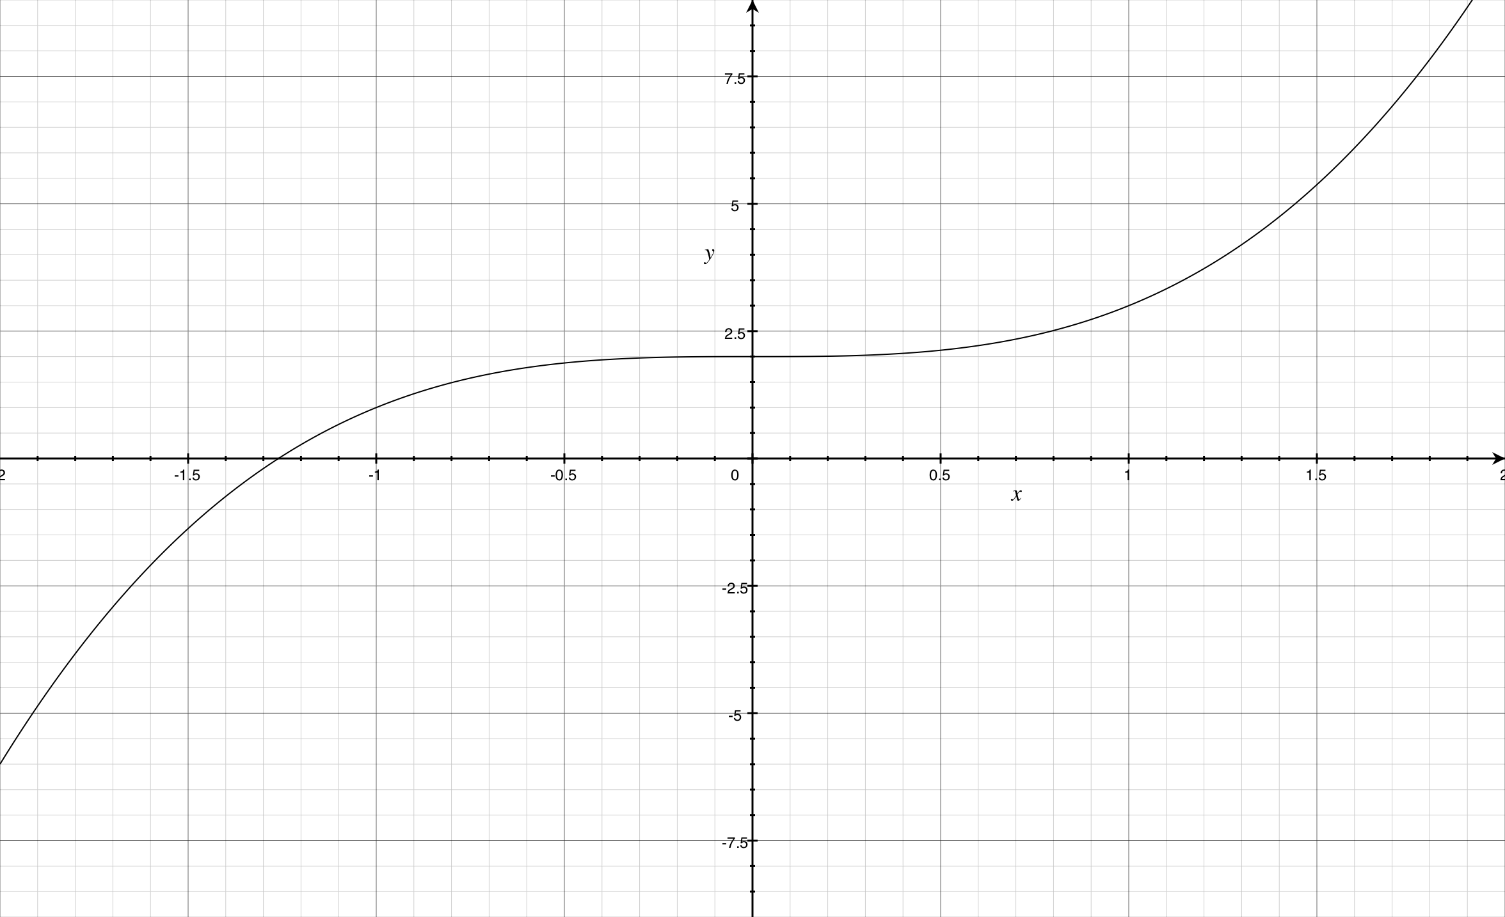  The graph of y = x³ + 2 is formed by translating the graph of y = x³ by two units upwards.
(ii) | 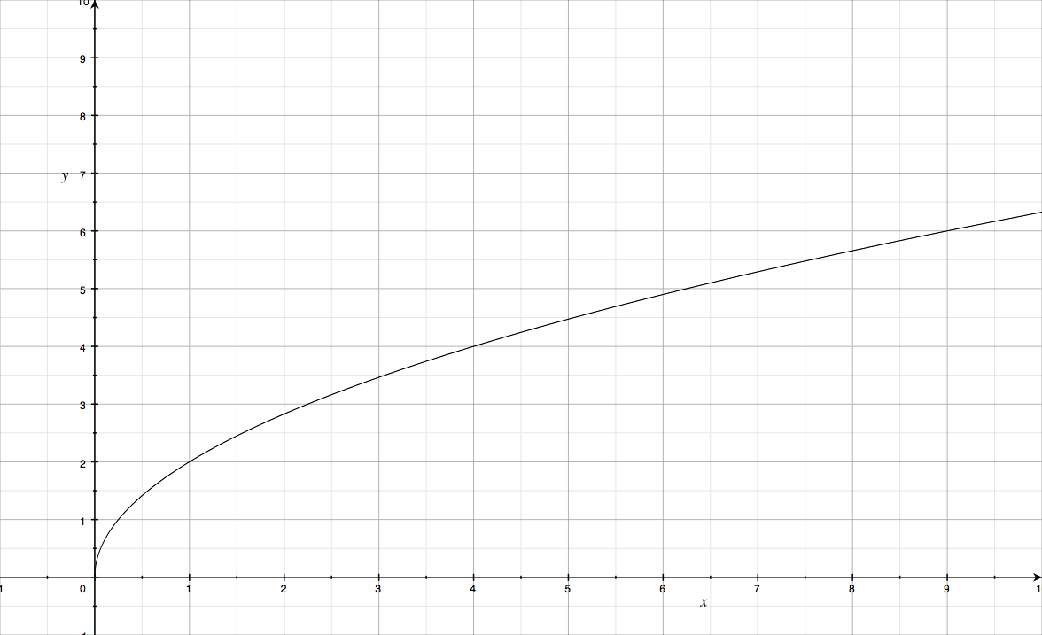  The graph of $y=2\sqrt{x}$ is formed by stretching the graph of $y=\sqrt{x}$ in the direction of the y-axis by a scale factor of 2.
(iii) | The transformation that transforms $y=2\sqrt{x}$ onto the curve $y=3\sqrt{x}$ is a stretch parallel to the y-axis scale factor 1.5.
6 (i) | The solutions of the quadratic equation ${\text{ax}}^{2}+\text{bx}+c=0$ can be found using the quadratic formula: $x=\frac{−b±\sqrt{b^{2}−4\text{ac}}}{2a}$  Here a = 1, b = 8 and c = 10.  So $x=\frac{−8±\sqrt{\text{64}−4´1´\text{10}}}{2}=\frac{−8±\sqrt{\text{24}}}{2}$  But $\sqrt{\text{24}}=\sqrt{4´6}=2\sqrt{6}$  Therefore the solutions are $x=\frac{−8±2\sqrt{6}}{2}\text{=-}4±\sqrt{6}$
(ii) | 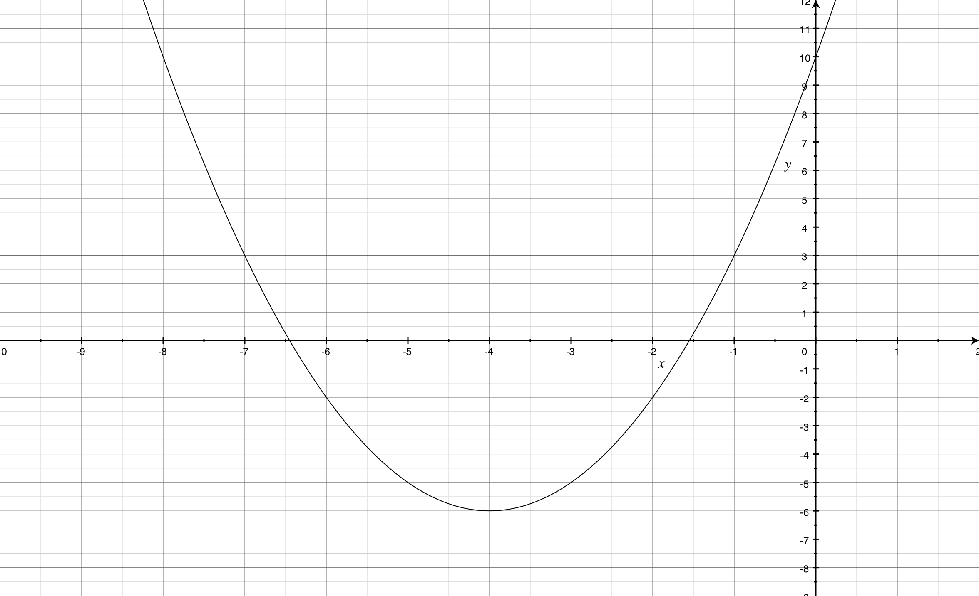  The curve cuts the y-axis at the point (0, 10).  The curve is a happy graph and cuts the x-axis at $−4+\sqrt{6}\text{, }−4−\sqrt{6}$ (both of which are negative values).
(iii) | From the sketch, the solutions of the inequality are:  $x\text{³-}4+\sqrt{6}$ or $x≤−4−\sqrt{6}$
7 (i) | To find the equation of the line, rearrange to the form y = mx + c:  x+ 2y = 4 i.e 2y = 4 – x i.e. y = 2 – 0.5x.  So the gradient is -0.5.
(ii) | A parallel line will have the same gradient, so the parallel line will have gradient -0.5.  The equation of a line with gradient m which passes through the point (a, b) is:  $y−y_{1}=m(x−x_{1})$  So  $y−5\text{=-}0\text{.}5(x−6)$  Multiply by 2:  $2y−\text{10}\text{=-}x+6$  Rearrange to get:  $x+2y−\text{16}=0$
(iii) | Rearrange the equation x + 2y = 4 to make y the subject: y = 2 – 0.5x.  Substitute this into the equation of the curve:  $2−0\text{.}5x=x^{2}+x+1$  Multiply by 2 to remove the fraction:  $4−x=2x^{2}+2x+2$  Rearrange to make one side equal to 0:  $2x^{2}+3x−2=0$.  This equation can be solved by factorising:  $2x^{2}+4x−1x−2=0$  $2x(x+2)−1(x+2)=0$  $(x+2)(2x−1)=0$  Therefore x = -2 or x = 0.5.  If x = -2, y = 2 – 0.5(-2) = 3  If x = 0.5, y = 2 – 0.5(0.5) = 1.75
8 (i) | To find the coordinates of the stationary points, the steps are:  - Differentiate the equation of the curve to get $\frac{\text{dy}}{\text{dx}}$  - Find the x-coordinates of the stationary points by solving $\frac{\text{dy}}{\text{dx}}$=0;  - Find the y-coordinates of each point using the equation of the curve.  Here $y=x^{3}+x^{2}−x+3$  Therefore:  $\frac{\text{dy}}{\text{dx}}=3x^{2}+2x−1$  To find the coordinates of the stationary points we solve $3x^{2}+2x−1$=0.  This can be solved by factorising:  $3x^{2}+2x−1=3x^{2}+3x−1x−1$  = 3x(x + 1) – 1(x + 1)  = (3x – 1)(x + 1)  So the solutions are x = 1/3 or x = -1.  When x =$\frac{1}{3}$, $y={\left(\frac{1}{3}\right)}^{3}+{\left(\frac{1}{3}\right)}^{2}−\frac{1}{3}+3=\frac{1}{\text{27}}+\frac{1}{9}−\frac{1}{3}+2=1\frac{\text{22}}{\text{27}}$  When x = -1, $y={\left(−1\right)}^{3}+{\left(−1\right)}^{2}−(−1)+3=4$  The coordinates of the stationary points are (-1, 4) and $\left(\frac{1}{3},1\frac{\text{22}}{\text{27}}\right)$.
(ii) | To decide whether the stationary points are maximums or minimums the steps are:  - Find the second derivative $\frac{d^{2}y}{{\text{dx}}^{2}}$  - Substitute each x value into the second derivative  - If $\frac{d^{2}y}{{\text{dx}}^{2}}>0,$ then it is a minimum;  If $\frac{d^{2}y}{{\text{dx}}^{2}}<0,$ then it is a maximum.  Here, $\frac{d^{2}y}{{\text{dx}}^{2}}=6x+2$  When x = -1, $\frac{d^{2}y}{{\text{dx}}^{2}}=6(−1)+2\text{=-}4<0$, i.e. a maximum point  When x = 1/3, $\frac{d^{2}y}{{\text{dx}}^{2}}=6(\frac{1}{3})+2=4>0$ i.e. a minimum point.
(iii) | We can sketch the graph of $y=x^{3}+x^{2}−x+3$:  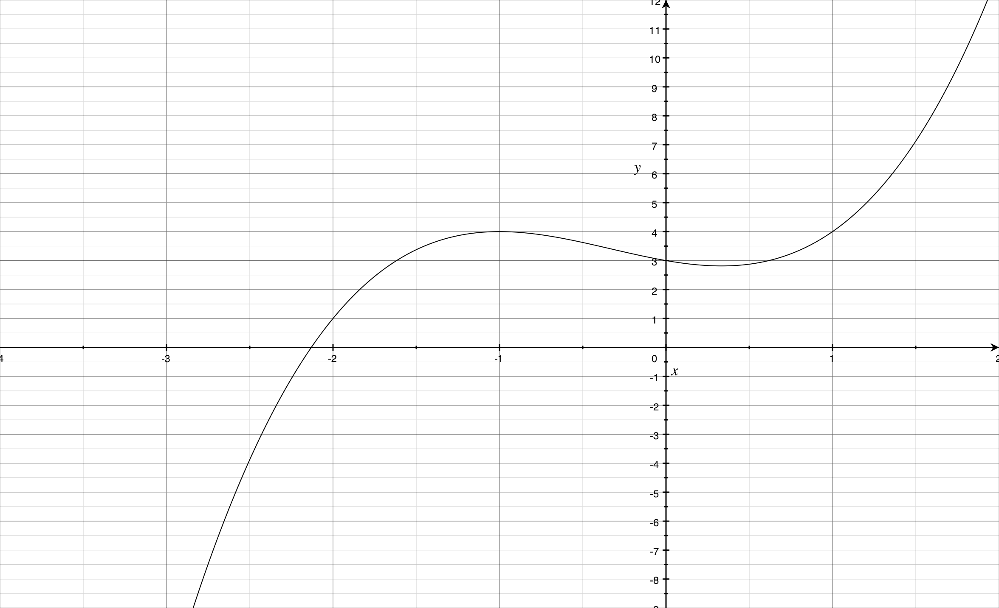  This shows that the curve is decreasing if -1 < x < 1/3.
9 (i) | The gradient of the line AB is $m=\frac{y_{2}−y_{1}}{x_{2}−x_{1}}$ (LEARN THIS!)  So the gradient is $m=\frac{1−(−2)}{3−(−5)}=\frac{3}{8}$  Using the formula $y−y_{1}=m(x−x_{1})$ for the equation of a straight line, we get:  $y−1=\frac{3}{8}(x−3)$  Multiply by 8 to remove the fraction:  $8y−8=3x−9$  Therefore: -3x + 8y + 1 = 0.
(ii) | The coordinates of the midpoint of AB are: $\left(\frac{−5+3}{2},\frac{−2+1}{2}\right)=(−1,−\frac{1}{2})$
(iii) | We can calculate the distance between two points using Pythagoras’s theorem (if we draw a sketch of the diagram) OR we can use the following formula:  $d=\sqrt{(x_{2}−x_{1})^{2}+(y_{2}−y_{1})^{2}}$  So: $d=\sqrt{(−3\text{--}5)^{2}+(1\text{--}2)^{2}}=\sqrt{2^{2}+3^{2}}=\sqrt{\text{13}}$
(iv) | Gradient of AC is $\frac{4−(−2)}{−3−(−5)}=\frac{6}{2}=3$  Gradeint of BC is $\frac{4−(1)}{−3−3}=\frac{3}{−6}\text{=-}\frac{1}{2}$  AC is not perpendicular to BC as the product of their gradients is not -1.  (Note: Two lines are perpendicular if the product of their gradients is -1, i.e. if the gradient of one line is the negative reciprocal of the gradient of the other).
10(i) | $f(x)=8x^{3}+\frac{1}{x^{3}}=8x^{3}+x^{−3}$ (Write as a negative power)  Therefore  $f'(x)=\text{24}x^{2}\text{+-}3x^{−4}=\text{24}x^{2}−3x^{−4}$  (Remember the rule for differentiating: bring down the power and subtract one from the old power).  So  $f\text{''}(x)=\text{48}x+\text{12}x^{−5}=\text{24}x^{2}−3x^{−4}$
(ii) | We have to solve:  $8x^{3}+\frac{1}{x^{3}}\text{=-}9$  Multiply by x³:  $8x^{6}+1\text{=-}9x^{3}$  So: $8x^{6}+9x^{3}+1=0$  This can be turned into a quadratic is we substitute $y=x^{3}$:  $8y^{2}+9y+1=0$  This can be solved by factorising;  $8y^{2}+8y+1y+1=8y(y+1)+1(y+1)=(8y+1)(y+1)$  So the solutions are y = -1 or $y\text{=-}\frac{1}{8}$  So:  $x=\sqrt[3]{y}=\sqrt[3]{−1}\text{=-}1 \text{or} x=\sqrt[3]{−\frac{1}{8}}\text{=-}\frac{1}{2}$

