Revision Topic 19: Angles

Angles and parallel lines

Recall the following types of angle:

Alternate angles (or Z angles) are equal: *

*

Corresponding angles (or F angles) are equal: *

*

Vertically opposite angles are equal:
*
*

Angles on a straight line add up to 180˚: x y x + y = 180

Angles around a point add up to 360˚: a
b
e
d c a + b + c + d + e = 360˚

Angles in triangles
x
The three angles inside a triangle add up to 180˚
y z x + y + z =180˚

Angles in quadrilaterals

The four angles inside a quadrilateral add up to 360˚.
a b

c
d

a + b + c + d = 360˚

Interior and exterior angles in polygons
The angles marked # are interior angles.

The angles marked * are exterior angles.

The interior and exterior angle at a corner of the shape add up to 180 degrees.

*
# # *

* # #
*
#
*

Sum of interior angles

We can find the sum of the (interior) angles for any polygon by splitting the polygon into non-overlapping triangles.

Example: Pentagon

A pentagon can be divided into 3 non-overlapping triangles.
As the triangles in each triangle add up to 180˚, the angles in a pentagon must add up to 3×180 = 540˚.

The same principle applies for any polygon:

Polygon | Number of sides | Number of non-overlapping triangles | Sum of interior angles
Triangle | 3 | 1 | 1 × 180 = 180˚
Quadrilateral | 4 | 2 | 2 × 180 = 360˚
Pentagon | 5 | 3 | 3 × 180 = 540˚
Hexagon | 6 | 4 | 4 × 180 = 720˚
Heptagon | 7 | 5 | 5 × 180 = 900˚
Octagon | 8 | 6 | 6 × 180 = 1080˚
General polygon | n | n - 2 | (n-2) × 180 = 180(n - 2)

Sum of exterior angles

The exterior angles for any polygon add up to 360 degrees.

Example:

Find the marked angles in these two diagrams:
50 130
125
a
50 60

80 85 b

65

The first diagram above concerns exterior angles. The sum of exterior angles in any shape is 360 degrees. Therefore angle a is 360 – (50 + 65 + 80 + 50) = 115˚.

The second diagram above concerns interior angles. The interior angles of a pentagon add up to 540˚. Therefore angle b is 540 – (85 + 125 + 130 + 60) = 140˚.

Regular Polygons

In a regular polygon all the interior angles are the same. Likewise all the exterior angles are the same.

Because the exterior angles add up to 360˚, each of them must be 360 ÷ n (where n is the number of sides).

Since each interior and exterior angle adds up to 180˚, the interior angles in a regular polygon with n sides must be $\text{180}−\frac{\text{360}}{n}$.

Example:
a) A regular polygon has 9 sides. Find the size of an interior angle.
b) A regular polygon has an exterior angle of 20˚. Show that the sum of the interior angles is 2880˚.

Solution:
a) Each exterior angle must be 360 ÷ 9 = 40˚. So the interior angles must be 180 – 40 = 140˚.

b) The exterior angle is 20˚. The number of sides must be 360 ÷ 20 = 18.
The interior angles must each be 180 – 20 = 160˚.
As there are 18 sides, sum of interior angles = 18 × 160 = 2880˚.

Examination Question
C
p
The diagram shows a regular pentagon ABCDE.
BD is parallel to XY.
Angle CBD = 36˚.
Work out the size of angles p, q and r.
36˚
B D
q

r
X A E Y
Angles in Circles

Circle Theorems

Theorem 1: The angle in a semi-circle is a right angle.

O

Theorem 2: Angles at the circumference are equal.
θ θ

Theorem 3: Angle at the centre is twice the angle at the circumference
θ

2θ
θ

2θ

A quadrilateral whose vertices ALL lie on the circumference of a circle is called a cyclic quadrilateral.

Theorem 4: Opposite angles of a cyclic quadrilateral add up to 180º.
α

β

α + β = 180˚

Example:
A
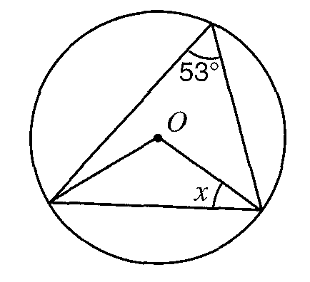

Angle BOC = 2 × 53˚ = 106˚ (the angle at the centre is twice the angle at the circumference).

Triangle BOC is isosceles (as OB and OC are equal since both radii of the circle).
Therefore x = (180 – 106)/2 = 37˚.

B C

Examination Question
In the diagram, O is the centre of the circle.
Angle COA = 100˚.
Calculate
- angle CBA;
- angle CDA.
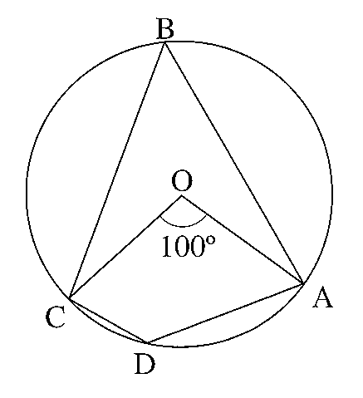

Examination Style Question:
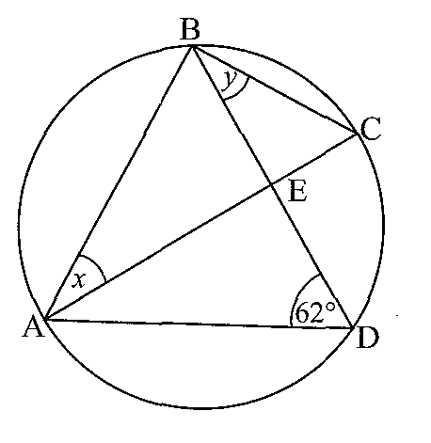
The diagram shows a circle with diameter AC.
a) i) What can you say about angles ADB and ACB?
ii) What is angle ABC? Explain your answer.
iii) Explain why x = 28˚.

b) If AD = BD, find y.

Tangents to circles

The tangent to a circle at a point is a line that just touches the circle at that point.

Theorem 5: Two tangents are drawn to a circle. One tangent touches the circle at A and the other touches the circle at B. If the tangents cross over at P, then PA = PB. If O is the centre of the circle then PO bisects angle AOB.
A

O

P

B

Theorem 6: The angle between a tangent and a radius is 90˚.

Examination Question

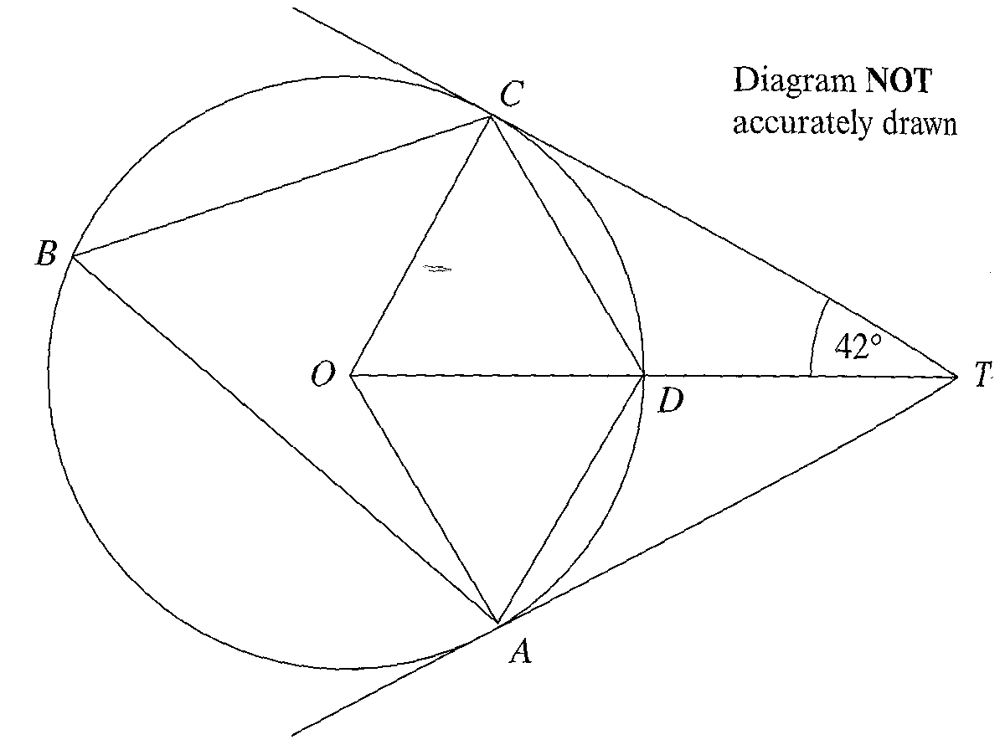
A, B, C and D are points on the circumference of a circle.
TA and TC are tangents to the circle.
The centre of the circle is at O.
ODT is a straight line.
Angle OTC = 42˚.
- Write down the size of angle OCT. Give a reason for your answer.
- Calculate the size of angle COT. Give reasons for your answer.

Grade A circle theorem: The Alternate Segment Theorem

The angle between a tangent and a chord is equal to any angle on the circumference that stands on that chord.

θ

θ

Examination Question
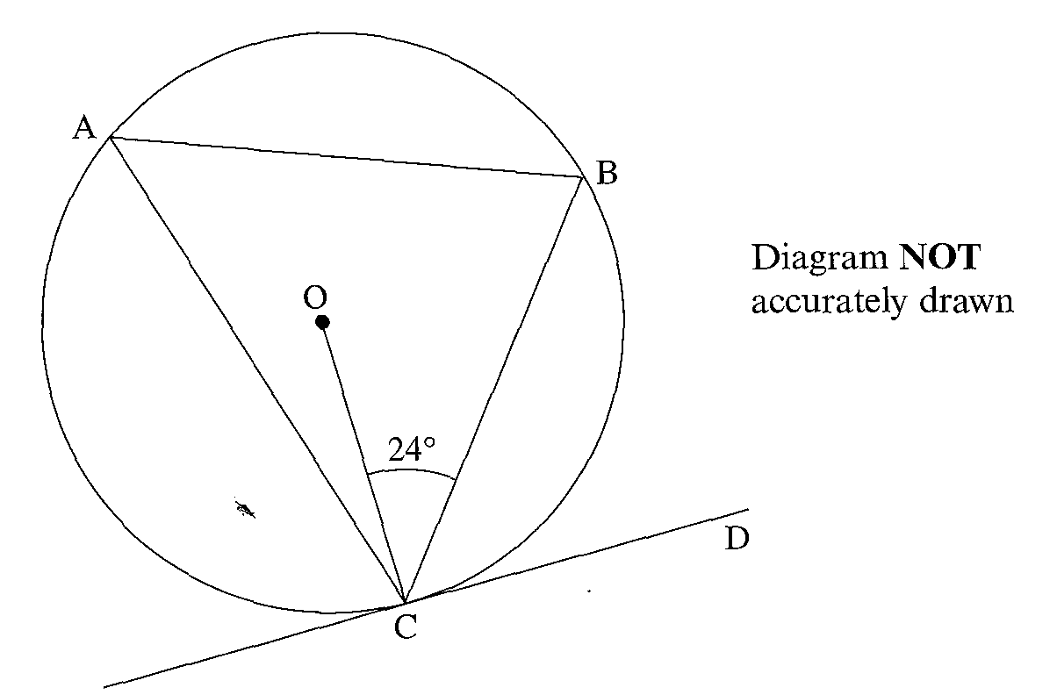
O is the centre of a circle.
CD is a tangent to the circle.
Angle OCB is 24˚.
a) Find the size of angle BCD. Give reasons for your answer.
b) Find the size of angle CAB. Give a reason for your answer.

