Schoolworkout
Maths
Recap: Independent Events

Example 1: I travel by bus and train on my journey to work. Given that P(bus late) is 0.3 and independently P(train late) is 0.2, calculate the probability that:
- both the bus and the train are late;
- either the bus or the train (or both) are late.

We can answer this question by drawing a tree diagram. Let B = bus late, T = train late.

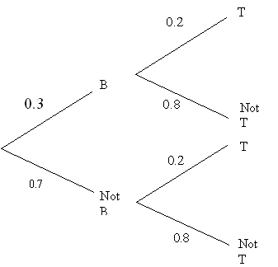
a) P(B and T) = 0.3 × 0.2 = 0.06

b) P(B OR T) = 1 – P(neither are late) = 1 – 0.7 × 0.8 = 0.44.

Example 2: Caroline plays a game with a fair coin. She keeps throwing the coin until a head is obtained, at which point she stops. Calculate the probability that:
- the game finishes on the 3rd throw;
- the game finishes in less than 5 attempts;
- the game continues for more than 10 throws.

a) P(game finishes on 3rd go) = P(Tail THEN Tail THEN Head) =
b) P(game finishes in less than 5 attempts) = P(finishes on 1st or 2nd or 3rd or 4th go)
But, P(game finishes on 1st go) = P(Head) =
P(game finishes on 2nd go) = P(T AND H) =
P(game finishes on 4th go) = P(T, T, T, H) =
So P(game finishes in less than 5 goes) =

c) P(game continues for more than 10 throws) = P(first 10 throws are tails) =
Dependent Events and Conditional Probability

Introductory example: The probability that it will be sunny tomorrow is . If it is sunny, the probability that Susan plays tennis is . If it is not sunny, the probability that Susan plays tennis is . Find the probability that Susan plays tennis.
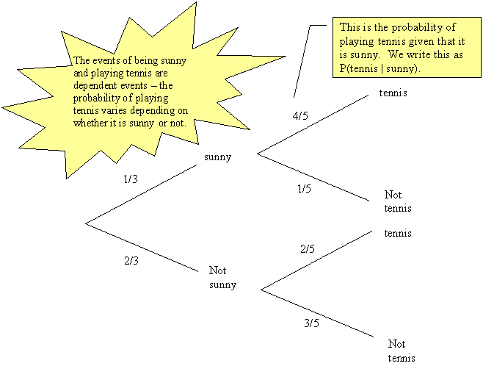

P(tennis) = P(sunny AND tennis) + P(not sunny AND tennis)
=

Example 2: On average I get up early 3 days out of 10, and get up late one day in 10.
I forget something on 2 out of every 5 days on which I am late and on one third of the days on which I am early. I do not forget anything on the days when I get up on time.
(a) Find the probability that I forget something.
(b) Confirm that for 80% of the time I am neither forgetful nor late.

Let E = get up early
T = get up on time
L = get up late
F = forget something
F’ = don’t forget anything

The tree diagram then looks as follows:
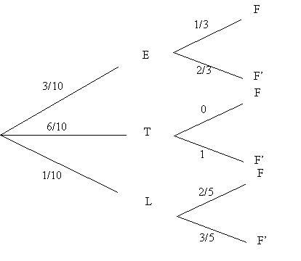
← part (b)
← part (b)

a) P(forget something) = P(E and F) + P(T and F) + P(L and F)
=

b) The two situations where I am neither forgetful nor late have been indicated on the tree diagram: So P(neither forgetful of late) =
Therefore, on 80% of occasions I will neither forget anything nor be late.

