Schoolworkout
Maths
Conditional Probability

Recap: Independent events.

If events A and B are independent, then the probability of B happening does not depend upon whether A has happened or not. Therefore

Probability of B given that A has occurred

and

.

A tree diagram can be drawn:

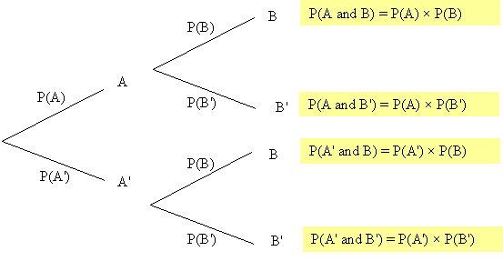

Dependent events:

If A and B are dependent events, the probability of B happening will depend upon whether A has happened or not.

We therefore have to introduce conditional probabilities in the tree diagram (as shown below):
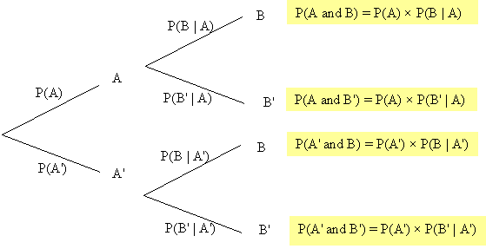

The rule for combining probabilities for dependent events is

P(A and B) = P(A) × P(B | A)

This is equivalent to saying

Example:
Every morning I buy either The Times or The Mail. The probability that I buy The Times is ¾ and the probability that I buy The Mail is ¼. If I buy The Times, the probability that I complete the crossword is , whereas if I buy The Mail the probability that I complete the crossword is .
a) Find the probability that I complete the crossword on any particular day.
b) If I have completed the crossword, find the probability that I bought The Mail.

The tree diagram is:
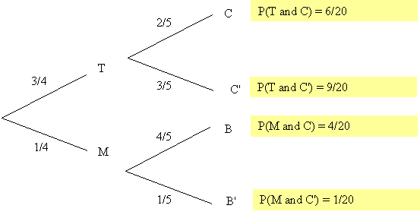

Notation: T = buy The Times M = buy The Mail C = complete crossword

a) From the tree diagram,
P(complete crossword) = P(T and C) + P(M and C) =

b) The probability that I bought The Mail given that I completed the crossword is given by

Example 2:
0.1% of the population carry a particular faulty gene.
A test exists for detecting whether an individual is a carrier of the gene.
In people who actually carry the gene, the test provides a positive result with probability 0.9.
In people who don’t carry the gene, the test provides a positive result with probability 0.01.
If someone gives a positive result when tested, find the probability that they actually are a carrier of the gene.

Let G = person carries gene P = test is positive for gene N = test is negative for gene
The tree diagram then looks as follows:

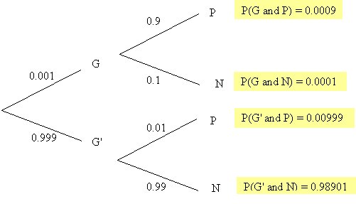

We want to find

However, P(P) = P(G and P) + P(G' and P) = 0.0009 + 0.00999 = 0.01089

Therefore, (to 3 significant figures)
So there is a very low chance of actually having the gene even if the test says that you have it.

Note: This example highlights the difficulty of detecting rare conditions or diseases.

Past Examination Question: (OCR)
Students have to pass a test before they are allowed to work in a laboratory. Students do not retake the test once they have passed it. For a randomly chosen student, the probability of passing the test at the first attempt is 1/3. On any subsequent attempt, the probability of failing is half the probability of failing on the previous attempt. By drawing a tree diagram or otherwise,
a) show that the probability of a student passing the test in 3 attempts of fewer is 26/27,
b) find the conditional probability that a student passed at the first attempt, given that the student passed in 3 attempts or fewer.

Solution:
Let P = pass test F = fail test

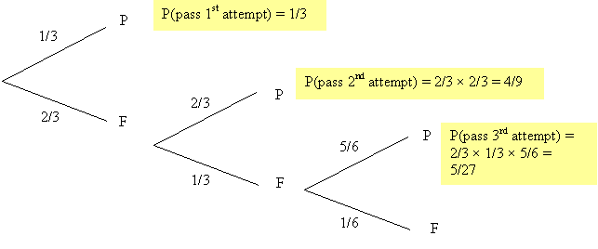

a) So P(pass in 3 attempts or fewer) = 1/3 + 4/9 + 5/27 = 26/27 as required

b) Let X stand for when a student passes the test.

We need .

But P(X = 1 and X ≤ 3) is the same as just P(X = 1).

Therefore

