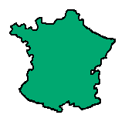France is our closest neighbour. We can travel there by many different ways. Its Capital is Paris. Their currency is the Euro.

Here are some words, which originate from France:
Ambush Buccaneer Cashier
Biscuit Flour Sir
Talk to the people in your group about what you think they mean. Now try to match the definition with the word. Look in an etymological dictionary- were you right?

From the word ‘fleur’
A word used for rank. It comes from an early word- sieur

Via the Latin
‘bis coctus’ meaning twice baked.

To hide in bushes
Name for a hunter who dried and stored meat on a wooden frame called a 'boucan’
Later for pirates

Means money-chest.

Now present your findings in an artistic way. Remember to use different fonts and look carefully at presentation.

