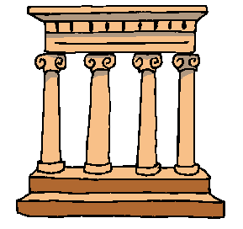Greece is a Country in the most Southern part of Europe. It is known for its ancient parts and of course the Olympics.

Here are some words, which originate from Greece:
Academy Dinosaur Hippopotamus

Church Helicopter Xylophone
Talk to the people in your group about what you think they mean. Now try to match the definition with the word. Look in an Etymological dictionary- were you right?
Two words
Heliko- Screw
Pteron- Wing
Named after a great Hero called Academus.
A gym was named after him.

Invented in 1841 from two words
Deinos- Terrible
Saurus- Lizard

From the word ‘Kyrios’ means Lord. This word means the house of the Lord.
Taken from two Greek words:
Xylo- wood
Phonos- sound

A horse found in a river

Now present your findings in an artistic way. Remember to use different fonts and look carefully at presentation.

