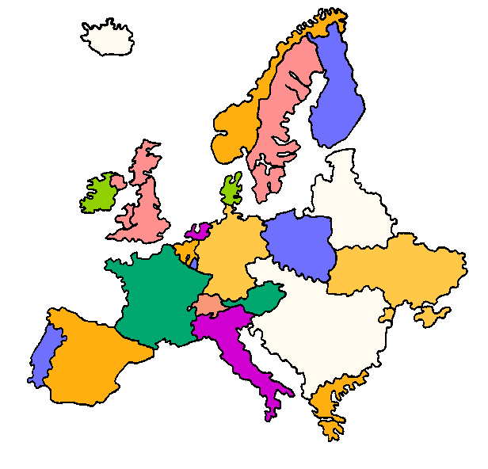Where do these words come from?
On the Map of Europe label the countries, which these words originate from. Use a dictionary to help you:

Aardvark Hippopotamus
Skipper Armadillo
Dinosaur Buccaneer
Xylophone

Where do you think Spaghetti comes from? Label the map carefully.

