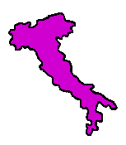Italy is known because of is shape. Its toe dips into the Meditteranean Sea and its head is covered in Mountains.

Here are some words, which originate from Italy:
Fiasco Oratorio Pianoforte

Spaghetti Carnival Terracotta
Talk to the people in your group about what you think they mean. Now try to match the definition with the word. Look in an etymological dictionary- were you right?
‘Cooked earth’
Is the word for a bottle or flask.

Comes from the word ‘oratory’ meaning a place of prayer

Harpsichord with soft and loud.

Word from the C16, taken from the word Carnevale. From the Latin carne ‘meat’ and levare ‘to put away’. Shrovetide was the name for the celebrations before people gave up eating meat for Lent.

Meaning little cords.

Now present your findings in an artistic way. Remember to use different fonts and look carefully at your presentation.

